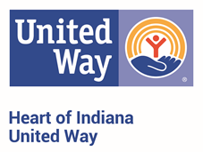
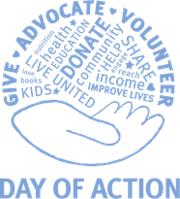
Day of Action 2021
Group Volunteer Sign-Up
Thursday, September 2, 2021

Company Name:

Number of Volunteers: /
AM PM

Group Contact Person | Preferred Project Type  (check or highlight all that apply)
Name: | - Yardwork/Landscaping
Phone: | - Office Cleaning/Painting
Email: | - Working with children
Volunteer T-Shirts
- We Would Like LIVE UNITED T-Shirts for our Volunteers
- Our Company will be Providing our Volunteers with T-Shirts

Schedule:
There will be a morning and an afternoon work shift for Day of Action, with a break for lunch. Participating nonprofits applied to have volunteers for a specific shift, or all day.

8:30-12pm Morning project shift at nonprofit sites
12-1pm Volunteers’ lunch break
Volunteers may get lunch on their own, or the nonprofit may provide lunch*
*You will be notified if your volunteer site is providing lunch
1:00-4:30pm Afternoon project shift at nonprofit sites
4:30pm Thank-you’s and photo ops

All volunteers are required to complete and return a volunteer waiver form.

Please complete and submit this form to Jim Flatford at jflatford@heartofindiana.org by 5pm on August 19th, 2021.

Volunteer Information Form
Due 8/28/20 by 5pm

Company Name:

Name | Shirt Size | Shift (AM/PM/Both)

